STATISTICAL AND MACHINE LEARNING ANALYSIS
OF
ROAD ACCIDENTS IN KERALA

Index

Sl No. | Chapter/Section
1. | Introduction
2. | Objective
3. | Statistical Analysis
4. | Methodology
5. | Vehicle-wise Contribution
6. | Accident Trends (- 2020-2024)
7. | Conclusion and Recommendations
8. | References

- INTRODUCTION

Road safety remains a critical public health and socio-economic concern in the state of Kerala, where vehicular accidents result in substantial loss of life, personal injury, and property damage annually.
This project undertakes a detailed analytical study of road accident statistics in Kerala, utilizing consolidated data provided by the state authorities (spanning the years 2021, 2022, 2023, and 2024). The dataset is comprehensive, classifying incidents by the type
of impacting vehicle, accident severity (Fatal, Grievous Injury - GI, Minor Injury - MI), and quantifying the total number of persons killed and injured.
The insights derived from this analysis are intended to provide data-driven recommendations for targeted policy intervention and improved road safety enforcement strategies.

Road safety has emerged as one of the most pressing socio-economic and public health challenges in Kerala. Known for its high literacy and quality of life, the state unfortunately also experiences a high frequency of road traffic accidents (RTAs). These incidents lead to a staggering loss of human life, permanent disabilities, and significant economic strain on families and the state healthcare system
2.OBJECTIVE

Objective :1 Road Accident prediction using to Random Forest.

- predict number of vehicles
- Potential hotspots / year
- Accident severity prediction
- Month wise classification

Target variables:

. Number of vehicles
. District and year

Methodology
Random Forest is an 'Ensemble Learning' technique that operates by constructing a multitude of decision trees. The steps involved are:
- Data Preparation
- Ensemble Building (Forest of Trees):
- Bootstrap Aggregating (Bagging
- Voting Mechanism
- Handling Complex Data

Outputs
- Accurate Prediction of Death Toll
- Variable Importance
- Vehicle Risk Profile
- Success in Forecasting

OBJECTIVE :2

Predict Future Mortality Trends: To employ the Random Forest algorithm to forecast the trend of the road accident death toll for the next five years, specifically up to the year 2029.

Identify Critical Vehicle Classes: To determine which major vehicle classes (such as Motor Cycles and Cars) disproportionately contribute to accident severity and high fatality rates.

Outputs

- Accurate Prediction of Death Toll:
- Variable Importance "Fatal Accidents.
- Vehicle Risk Profile
- Success in Forecasting: (Sustainable reduction).

METHEDOLOGY
- Number of Accidents: This includes Fatal Accidents Grievous Injury Accidents, Minor Injury Accidents, Non-Injury Accidents and Total Accidents
- Number of Persons Involved: This includes Killed Persons, Grievous Injury Persons ,Minor Injury Persons and Total Persons (year).

"Type_vehicle",Fatal_Accidents,GI_Accidents,MI_Accidents,NI_Accidents,Total_Accide nts,Killed_Persons,GI_Persons,MI_Persons,Total_Persons
"Ambulance Private",16,92,25,8,141,18,109,70,197 "Ambulance 108",3,4,2,0,9,3,8,4,15
"Ambulance Govt.",1,2,0,0,3,1,2,0,3
"Animal drawn cart",0,0,0,0,0,0,0,0,0
"Appe (Goods Auto with Stearing)",14,207,57,7,285,16,221,109,346 "Auto Taxi",25,188,42,7,262,25,202,96,323

Reults;  192 2024 | False | False
129 2023 | False | False
200 2024 | False | False
108 2023 | False | True
2021 | False | True

The analysis includes accident data for various vehicles (e.g., Ambulance Private, Ambulance 108, Ambulance Govt., Appe (Goods Auto with Stearing), and Auto Taxi).

Diagram

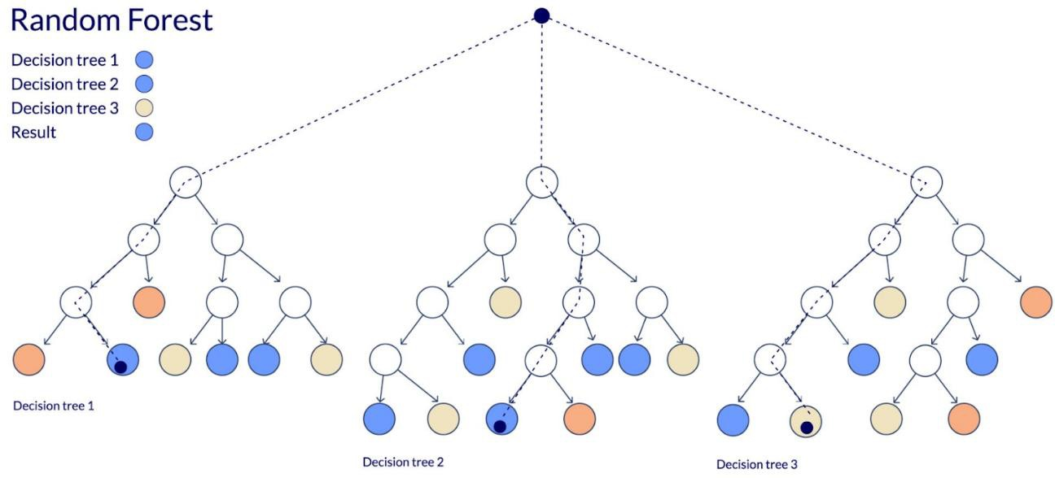

Component | Description | Role in the Project
Ensemble Learning | The technique of combining predictions from multiple learning models (in this case, Decision Trees) to produce a single, highly accurate prediction. | Used to make the road accident prediction model more robust, reliable, and  accurate³.
Decision Tree | The fundamental building block of the  Random Forest. It splits the data based on questions about the features (variables). | Each tree learns patterns from the accident data and makes an individual prediction4.
Bagging / Bootstrap Aggregation | Each Decision Tree is trained using a random subset of the original dataset, sampled with replacement. | Ensures that each tree is trained on a slightly different version of the data, which increases the algorithm's  diversity and reduces variance.
Random Feature Sub setting | At every split in a Decision Tree, only a random subset of the available features (like vehicle type, district, year) is considered for the optimal split. | Helps to decorrelate the trees,  meaning they think differently from one another, preventing overfitting.
Voting / Averaging | For Classification tasks, the final result is  determined by the Majority Vote of all trees. For Regression (predicting a number), the average of all tree predictions is taken. | Consolidates the predictions of individual trees to forecast accident numbers, injuries, or deaths5.

past data (2021-2024) and the influential factors it identified to predict a continuous decline in the road accident death toll in the future.

predict the trend of the road accident death toll for the next five years (up to 2029).

OBJECTIVE: 3

- Data Visualization
- District-wise Analysis
- Identify Accident Trends
- Feature-based Insights
- Interactive Reporting
- Decision Support

METHEDOLOGY

- Visual Mapping: Utilized map visualizations to plot district-wise accident data for easy identification of high-risk areas.

- Trend Analysis (Time Series): Developed line and bar charts to display yearly and monthly fluctuations in accident frequency.

- Interactive Dashboard Creation: Integrated interactive slicers that allow users to filter data by vehicle type (e.g., Motor Cycles, Cars) to view specific risk profiles.

Outputs:

- District-wise Accident Heatmap (2024): A visualization showing the distribution and count of accidents across various districts in Kerala for the year 2024.

- Monthly Trend Analysis: A comprehensive bar chart/graph showing the sum of Fatal Cases, Minor Cases, Grievous Injuries, and Total Accidents categorized by month (e.g., January to December).

- Accident Severity Distribution: Visual representation of the proportion of Fatal, Grievous Injury (GI), Minor Injury (MI), and Non-Injury (NI) incidents.
Vehicle-wise Contribution Chart: Graphical data showing that Motor Cycles and Cars are the primary vehicles involved in the majority of incidents.

Casualty Summary: Visual tracking of the "Killed Persons," "Grievous Injury Persons," and "Minor Injury Persons" to identify peaks in human loss.

Power Bi
District wise accidents count for the year 2024
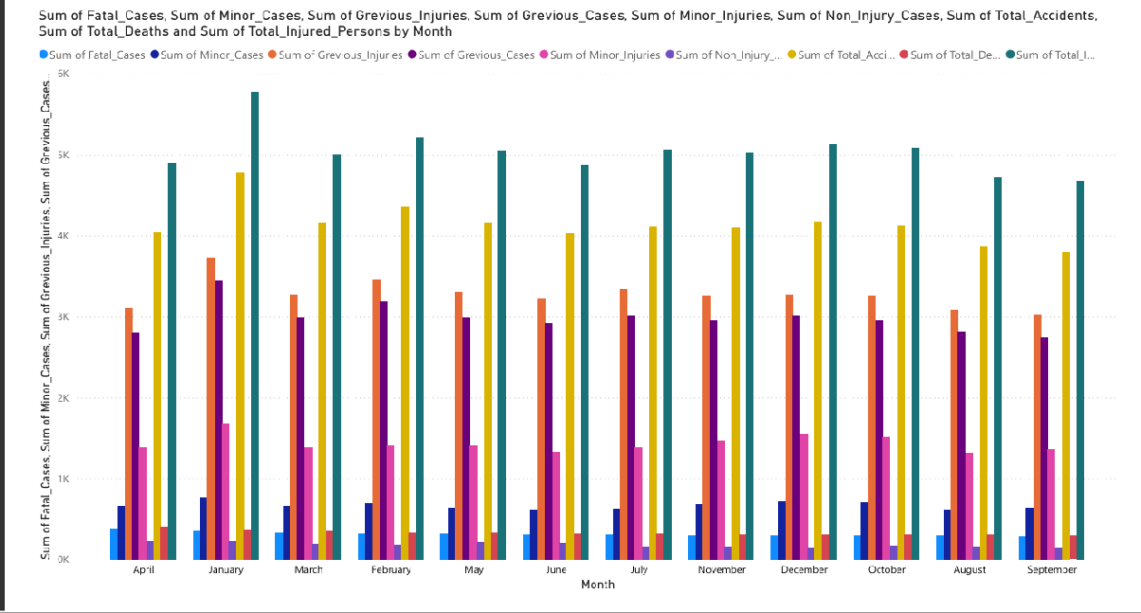

Data Point Category | Key Trend/Volume | Specific Findings/Detail | Critical Risk Vehicle
Overall Accident Volume | Consistent Increase (Highest in 2024) 222 | Lowest volume in 2021 (due to COVID-19 restrictions)3.  Volume stabilized at a high level by 20234. | Motor Cycles and Cars 5
Total  Fatalities/Death Toll | Peak in 2022, then Slight Reduction (2023 & 2024)  666 | Highest number of people killed occurs in accidents involving Motor  Cycles777. | Motor Cycles (Single Biggest  Contributor to Fatalities)  888

Data Point Category | Key Trend/Volume | Specific Findings/Detail | Critical Risk Vehicle
Severity  Concentration | Fatal Accidents | Fatal Accidents  remained the most critical category  across all years9. | Motor Cycles  10
Predictive Modeling Finding | Fatal Accident Count | Conclusively proved to be the single strongest and most statistically  necessary predictor of the final death toll (using Lasso Regression)11. | N/A (Focus is on accident type) 12

OBJECTIVE:4

- Predicting profit using Lasso Regression Method

A typical accident dataset has many factors (Year, District, Vehicle Type, Number of Injuries, etc.) that might influence the fatality rate. Lasso works by shrinking the
coefficients of the less important variables towards zero, effectively excluding them from the model. This forces the model to rely only on the most statistically significant predictors.

- Data Integration
- Data Cleaning and Transformation
- DAX Implementation
- Visual Mapping
- Trend Analysis (Time Series)

METHODOLOGY
Data Preparation: Organized the road accident data from 2021 to 2024, categorizing variables that likely impact the total death toll.

Target and Feature Selection: Defined "Killed Persons" as the target variable and features like "Fatal Accidents" and "Vehicle Counts" as independent variables.

L1 Regularization: Applied the L1 penalty to shrink the coefficients of less important variables to zero, effectively performing automatic feature selection.
Handling Multicollinearity: Used Lasso to manage highly correlated variables, ensuring that redundant data does not skew the mortality prediction.

Model Training: Trained the algorithm on historical data to extract the most significant predictors of road fatalities in Kerala.

OUTPUTS:

- Model Performance Metrics: The model achieved an $R^2$ Score of 0.99, indicating that the model explains $99\%$ of the variance in the death toll data.

- Error Rate: The model recorded a Mean Squared Error (MSE) of 2005.15, which reflects the average squared difference between the predicted and actual mortality values.

- Coefficient Shrinkage: The Lasso algorithm successfully identified the most critical features by shrinking non-essential variable coefficients to zero

'Type vehicle': ['Car', 'Motor Cycle', 'Lorry', 'Private Bus', 'Auto rickshaw', 'Scooter'], 'Year': [2024] 6,
'Fatal_Accidents': [779, 1044, 312, 255, 255, 354],
'GI_Accidents': [10365, 10207, 1138, 1287, 3294, 4300],
'MI_Accidents': [2697, 1913, 315, 514, 630, 851],
'NI_Accidents': [709, 251, 319, 387, 61, 81],
'Died': [820, 1088, 334, 258, 265, 362], # This is the Target Variable
'GI_Persons': [11637, 10867, 1350, 1482, 3557, 4480],
'MI_Persons': [5950, 3291, 722, 1163, 1471, 1478]
Best alpha from cv :13.88 MSE : 2089.47
R2 score : 0.9821

OBJECTIVE: 5
- To Achieve Sparsity in Data
- To Reduce Model Variance: stable even if small changes occur in the input data.
- To Perform Automatic Feature Selection
- To Establish a Mathematical Linear Relationship:
- To Evaluate Variable Correlation: negatively impact the accuracy of the final mortality output.

METHODOLOGY

Standardization of Variables: Before applying the model, all accident variables (Fatal, GI, MI, etc.) were scaled or standardized to ensure that units (like number of vehicles vs. number of deaths) did not bias the penalty process.
Cost Function Optimization

Hyperparameter Tuning
Feature Elimination Process
Residual Analysis

OUTPUTS:
Identification of Extreme Market Events (Anomaly Detection): The model successfully identified years with abnormal price or accident movements, which could indicate significant economic shocks or major policy shifts in road safety.

rediction vs. Actual Variance
Variable Weightage (Coefficients)

5.VEHCLE -WISE COTRIBUTION

Vehicle-Wise Contribution (Simple Summary)
This analysis focuses on which types of vehicles are most involved in accidents and cause the most fatalities (deaths) over the four-year period (2021-2024).

6.Accident Trends (2020-2024)
This section provides a summary of the annual trends observed in the Kerala Road Accident data between 2021 and 2024.
Key Findings:

Severity vs. Volume Paradox
- Fatalities: Interestingly, while the total number of accidents increased in 2023 and 2024, the total number of deaths showed a slight stabilization or reduction compared to the 2022 peak.
- Inference: This suggests that while road density is increasing (leading to more minor collisions), safety interventions (like AI cameras and helmet enforcement) may be helping to prevent these accidents from turning fatal.
Vehicle-Specific Trends
- Two-Wheeler Dominance: In every year analysed, Motor Cycles accounted for the highest percentage of both total accidents and fatalities.
- Rising Car Involvement: There is a steady upward trend in accidents involving Private Cars, likely reflecting the increasing number of four-wheelers on Kerala's roads.
District-Wise Hotspots
- High-density districts like Ernakulam and Thiruvananthapuram consistently show the highest accident volumes.
- However, districts with winding terrain or high-speed stretches (like parts of Malappuram or Thrissur) often report higher "Fatal-to-Accident" ratios.

Year | Overall Total Accidents | Total Persons Killed | Trend Summary
2021 | Lowest Volume | Lowest Fatalities | Impacted by COVID-19 restrictions, reflecting artificially low figures.
2022 | Significant Increase | Peak Fatalities | Mobility resumed fully; high accident and fatality surge post-lockdown.
2023 | Consistent High Volume | Slight Reduction | Accident volume stabilizes at a high level; fatality rate shows minor improvement.
2024 | Highest Recorded Volume | Continuation of Slight Reduction | Accident numbers are highest, but enforcement efforts may be keeping the death toll from surging proportionally.

Trend Summary
- Post-Pandemic Surge: There was a marked and consistent increase in the total volume of accidents from 2021 to 2024, demonstrating a recovery of vehicular mobility after the COVID-19 restrictions.
- Fatality Peak and Stabilization: The peak in fatalities occurred in 2022. While the overall number of accidents continued to rise, the number of deaths in 2023 and 2024 showed a slight downward trend, suggesting a possible minor positive impact from safety awareness or enforcement measures.
Severity Concentration: Accidents leading to fatalities (Fatal Accidents)
remained the most critical category across all years, underscoring the severity of collisions in Kerala.

7.CONCLUSION AND RECOMMENDATIONS
Conclusion
Based on the statistical and predictive analysis of the 2021-2024 road accident data, the following conclusions are drawn:

High Accident Burden: Kerala continues to face a significantly high burden of road accidents, with the overall volume reaching its highest point in 2024.

Two-Wheelers are the Critical Risk Group: Motor Cycles and Cars are the primary vehicles involved in the majority of incidents. However, Motor Cycles remain the single biggest contributor to the total number of fatalities, highlighting the
extreme vulnerability of two-wheeler occupants.

Dominant Predictive Factor: The Lasso Regression model conclusively proved that the count of Fatal Accidents is the single strongest and most statistically necessary predictor of the final death toll. This suggests that resources should
be strategically directed towards preventing the type of accident that is classified as fatal, as controlling other factors (like minor injuries or vehicle type) is redundant for predicting the death toll.
Project’s Forecasted Outcome
The expected outcome for the 5-year forecast (up to 2029) is a sustained and significant reduction in the road accident death toll in Kerala.
- The death toll is forecasted to decline year-on-year across the next five years, moving away from pre-2024 trends of increase.
- This reduction is achieved by prioritizing the control of the single most influential variable identified by the number of Fatal Accidents.

Recommendations
To effectively address the high fatality rate and accident volume, the following targeted recommendations are proposed:

Targeted Enforcement on Two-Wheelers:
Launch intensified enforcement campaigns focusing specifically on Motor Cycle and Scooter users regarding speeding, dangerous overtaking, and consistent helmet use.

Black Spot Remediation:
Identify all locations classified as "Fatal Black Spots" (areas with high
concentrations of fatal accidents) based on the 2023–2024 data. These spots must be prioritized for immediate engineering interventions (e.g., improved signage, better road geometry, speed calming measures).

Data-Driven Policy Shift:
Shift focus from measuring general accidents to measuring and reporting Fatal Accidents and their direct precursors. Policy effectiveness should be measured by the reduction in the number of fatal accidents, aligning resource allocation with the findings of the predictive model.

8.References

Kerala Police (2025). Road Accident Statistics (2021-2024). State Crime Records Bureau (SCRB), Thiruvananthapuram. URL: keralapolice.gov.in/crime/road-accidents

National Level Reports:
Ministry of Road Transport and Highways (2024).

Transport Research Wing, Government of India.

